# Table creation

### Patients

create table Patients(

Patient_id int primary key,

Name varchar2(50),

Age int ,

Gender char(1)

);

### Doctors**:**

create table Doctors(

Doctor_id int primary key,

Name varchar2(50),

Speciality VARCHAR2(50)

);

### Visits:

Create table Visits(

Visit_id int primary key ,

Patient_id int ,

Doctor_id int,

Visit_date Date,

Diagnosis Varchar2(100),

Fee Decimal(8,2),

Constraint fk_doctor_id FOREIGN Key(Doctor_id) references Doctors(Doctor_id)

);

# Data Insertion

### **Patients**

INSERT INTO Patients VALUES (1, 'Alice Smith', 28, 'F');

INSERT INTO Patients VALUES (2, 'Bob Johnson', 35, 'M');

INSERT INTO Patients VALUES (3, 'Carol Davis', 42, 'F');

INSERT INTO Patients VALUES (4, 'David Wilson', 23, 'M');

INSERT INTO Patients VALUES (5, 'Eva Brown', 30, 'F');

INSERT INTO Patients VALUES (6, 'Frank Moore', 50, 'M');

INSERT INTO Patients VALUES (7, 'Grace Taylor', 19, 'F');

INSERT INTO Patients VALUES (8, 'Hank Miller', 60, 'M');

#### Screenshot**:**

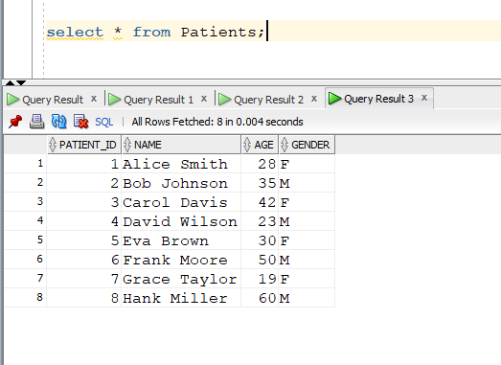

### Doctors

INSERT INTO Doctors VALUES (101, 'Dr. Allen', 'Cardiology');

INSERT INTO Doctors VALUES (102, 'Dr. Baker', 'Neurology');

INSERT INTO Doctors VALUES (103, 'Dr. Clark', 'Endocrinology');

INSERT INTO Doctors VALUES (104, 'Dr. Davis', 'General Medicine');

#### Screenshot:

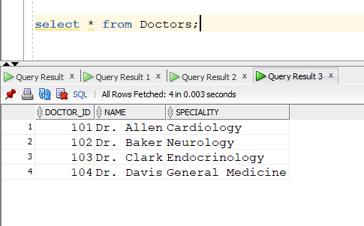

### Visits

INSERT INTO Visits VALUES (1001, 1, 101, TO_DATE('2023-01-10', 'YYYY-MM-DD'), 'Cold', 100.00);

INSERT INTO Visits VALUES (1002, 2, 101, TO_DATE('2023-02-12', 'YYYY-MM-DD'), 'Flu', 150.00);

INSERT INTO Visits VALUES (1003, 3, 101, TO_DATE('2023-03-15', 'YYYY-MM-DD'), 'Chest Pain', 200.00);

INSERT INTO Visits VALUES (1004, 4, 101, TO_DATE('2023-04-20', 'YYYY-MM-DD'), 'High BP', 180.00);

INSERT INTO Visits VALUES (1005, 5, 101, TO_DATE('2023-05-10', 'YYYY-MM-DD'), 'Fever', 120.00);

INSERT INTO Visits VALUES (1006, 6, 101, TO_DATE('2023-06-01', 'YYYY-MM-DD'), 'Diabetes', 300.00);

INSERT INTO Visits VALUES (1007, 1, 102, TO_DATE('2023-06-20', 'YYYY-MM-DD'), 'Migraine', 250.00);

INSERT INTO Visits VALUES (1008, 2, 103, TO_DATE('2023-07-15', 'YYYY-MM-DD'), 'Diabetes', 350.00);

INSERT INTO Visits VALUES (1009, 7, 103, TO_DATE('2023-08-01', 'YYYY-MM-DD'), 'Diabetes', 150.00);

INSERT INTO Visits VALUES (1010, 3, 104, TO_DATE('2023-08-18', 'YYYY-MM-DD'), 'Checkup', 80.00);

#### Screenshot**:**

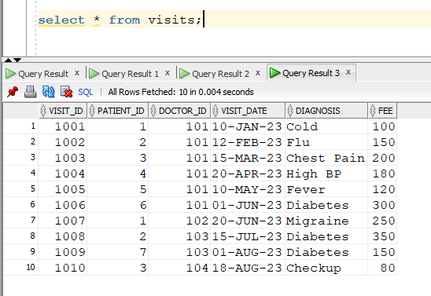

# Problem Solution

### Ques a)

List the names of doctors who have treated more than 5 different patients

#### Query**:**

**select doctors.name from doctors inner join (Select Visits.Doctor_id from Visits**

**Group by visits.doctor_id Having count(Visits.Patient_id)>5) sec**

**ON sec.doctor_id = doctors.doctor_id;**

#### Screenshot:

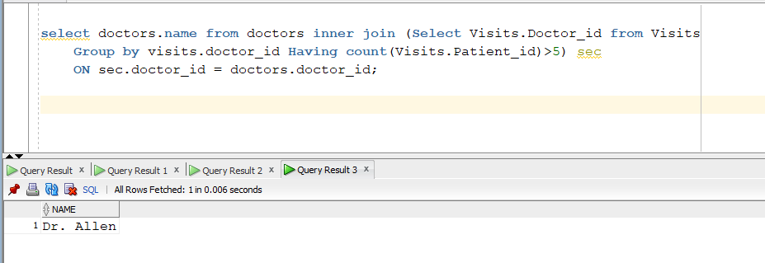

### Ques b)

For each doctors , show the total revenue they generated from visit fees .

#### Query**:**

**select Doctors.Doctor_id , doctors.name , Total_Revenue doctors from Doctors inner join (Select Visits.Doctor_id ,sum(fee) as Total_Revenue from Visits**

**Group by visits.doctor_id ) sec**

**ON sec.doctor_id = doctors.doctor_id**

**Order by Total_Revenue;**

#### Screenshot:

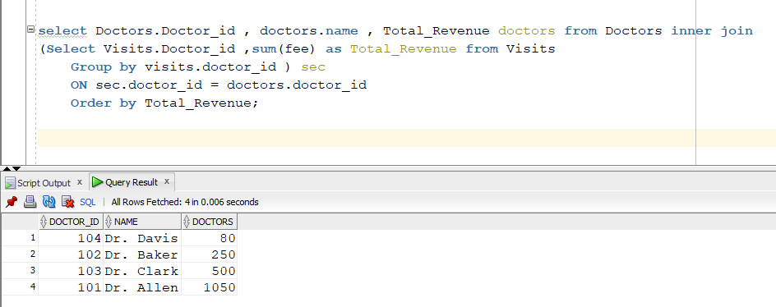

### Ques c)

**Find the name and age of the youngest patient who has diagnosed with ‘Diabetes’**

#### Query:

**Select Patients.Name , Patients.age**

**from Patients**

**inner join Visits**

**on Patients.Patient_Id = Visits.Patient_id**

**where Visits.Diagnosis = 'Diabetes'**

**order by Patients.age**

**fetch first 1 rows only;**

#### Screenshot:

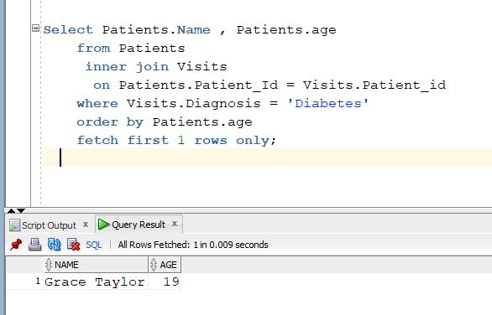

### Ques d)

**Display the specialty of the doctor who earned the highest total revenue.**

#### Query :

**select Speciality**

**from Doctors inner join Visits**

**on Doctors.Doctor_id = visits.Doctor_id**

**group by visits.Doctor_id , Doctors.Speciality**

**order by sum(fee) desc**

**fetch first 1 rows only;**

#### Screenshot:

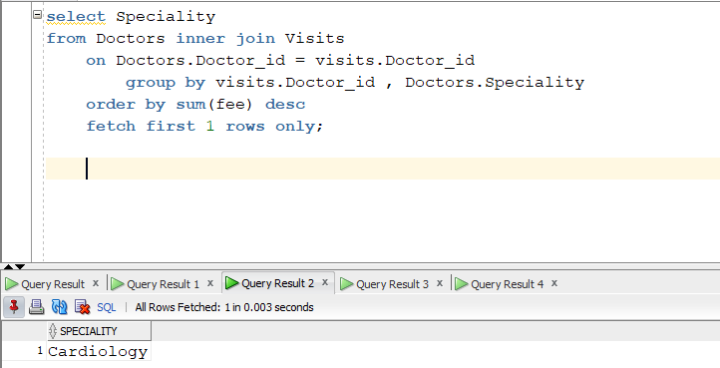

### Ques e)

**List the name of the patients who have never visited a doctor.**

#### Query:

**select Name , Patient_id**

**from Patients**

**where Patients.Patient_id**

**not in (select Patient_id from visits group by patient_id);**

#### Screenshot:

